**INFOLABZ IT SERVICES PVT. LTD.**

**Course :** React

**Session No :**

**Topics to be covered :** CSS in depth, React component with CSS , CSS box properties

| **Project Name** | reactcssone | | |
| --- | --- | --- | --- |
| **Component Name** | **Type of css** | **Use** | **Properties** |
| Login | Inline | Button | Button color : red , font on button white, add size |
| Box | external | Division | Height, width, border, radius |
| Table | Document level | Table | Border color, border thickness, font, all align center |
| One | external | Division | Box with margin, padding , height, width, border radius, border color |

| **Project Name** | reactcsstwo | | |
| --- | --- | --- | --- |
| **Component Name** | **Type of css** | **Use** | **Properties** |
| Tableone | Any | Table | Change table height, table width, row height, column width, table border type ( solid/dotted etc ), border color etc… |
| Image | Any | Image | Change Image height, width, apply radius to image, apply shadow to the image. |
| Box | Any | Division | Add height,width to the box, apply shadow, apply radius to the top corners of the box only |
|  |  |  |  |

Project : Imagegallery ( custom js files )

| Table.js | Create image gallery using table. Table row 1 image , Table row 2 Movie name, Table row 3 category, table row 4 image, table row 5 movie name …. **EXAMPLE 1** |
| --- | --- |
| Marquee.js | Image tag , Marquee tag, div tag (rotating right to left ) **EXAMPLE 2** |
| Divtag.js | Image gallery as shown in **EXAMPLE 3** using div tag |

EXAMPLE 1 :

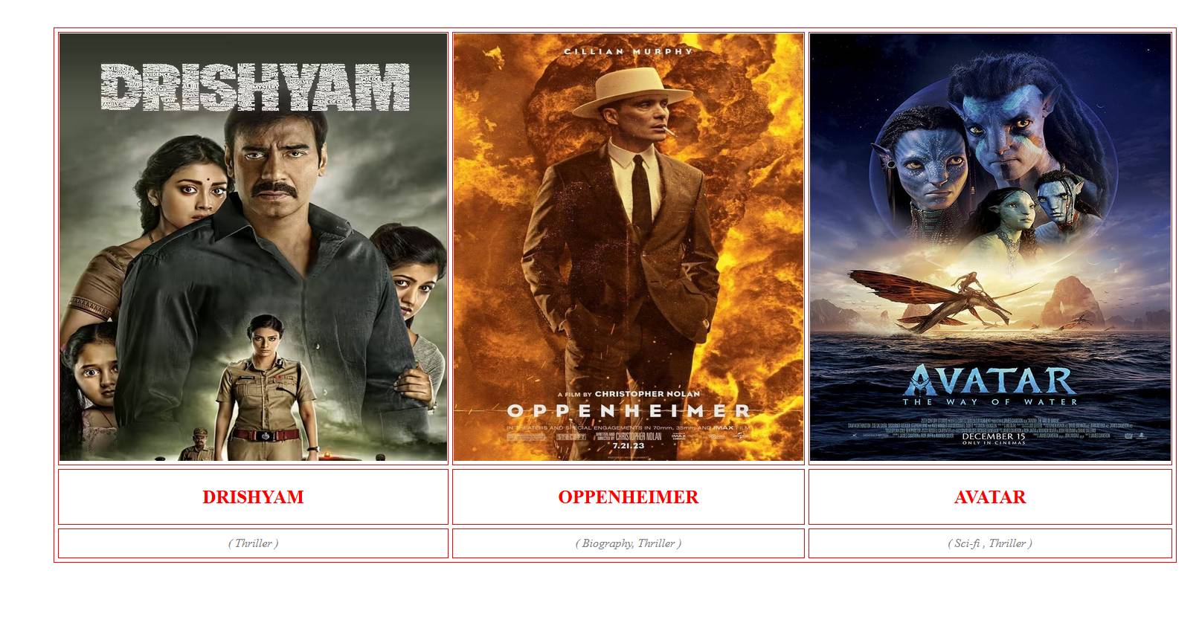

After changing border thickness to 0

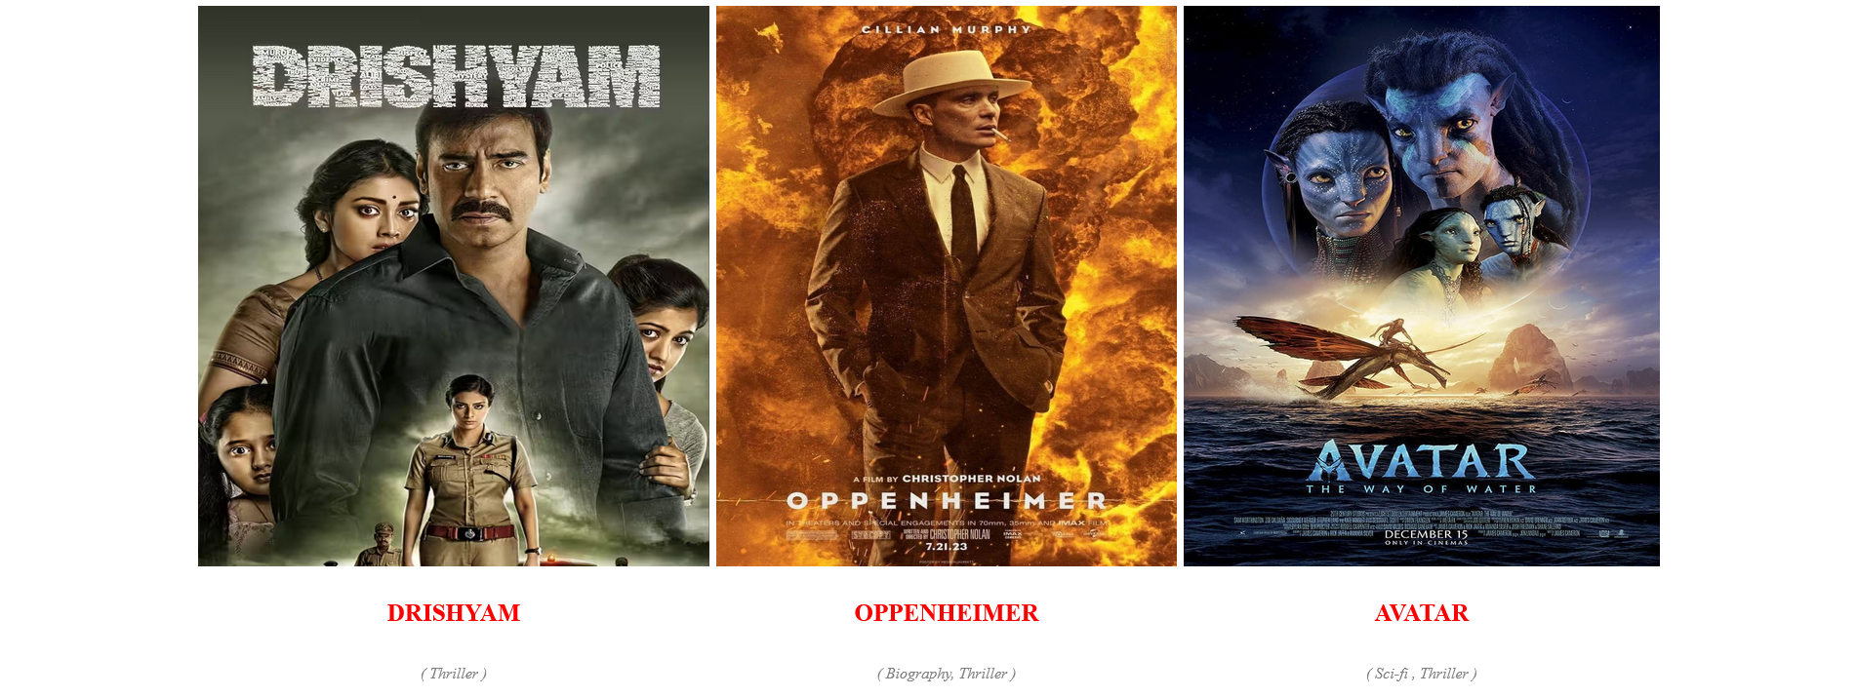

EXAMPLE : 2

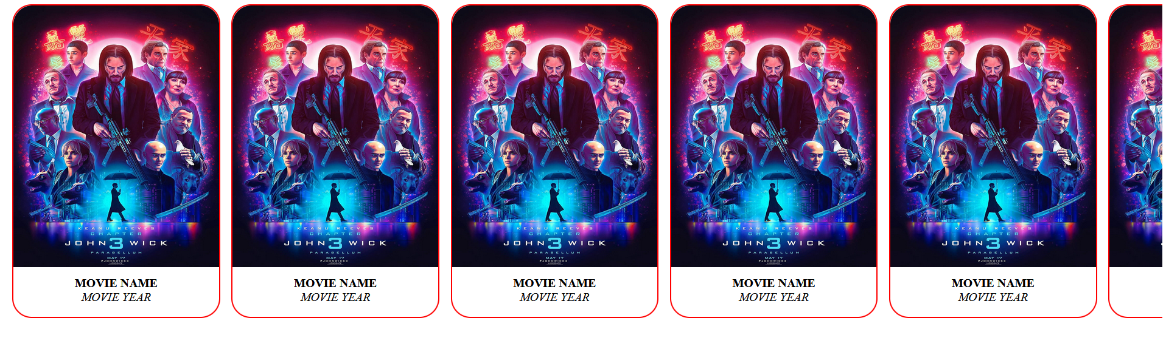

( Above image gallery movie from right to left, on mouse hover marquee stops )

EXAMPLE : 3

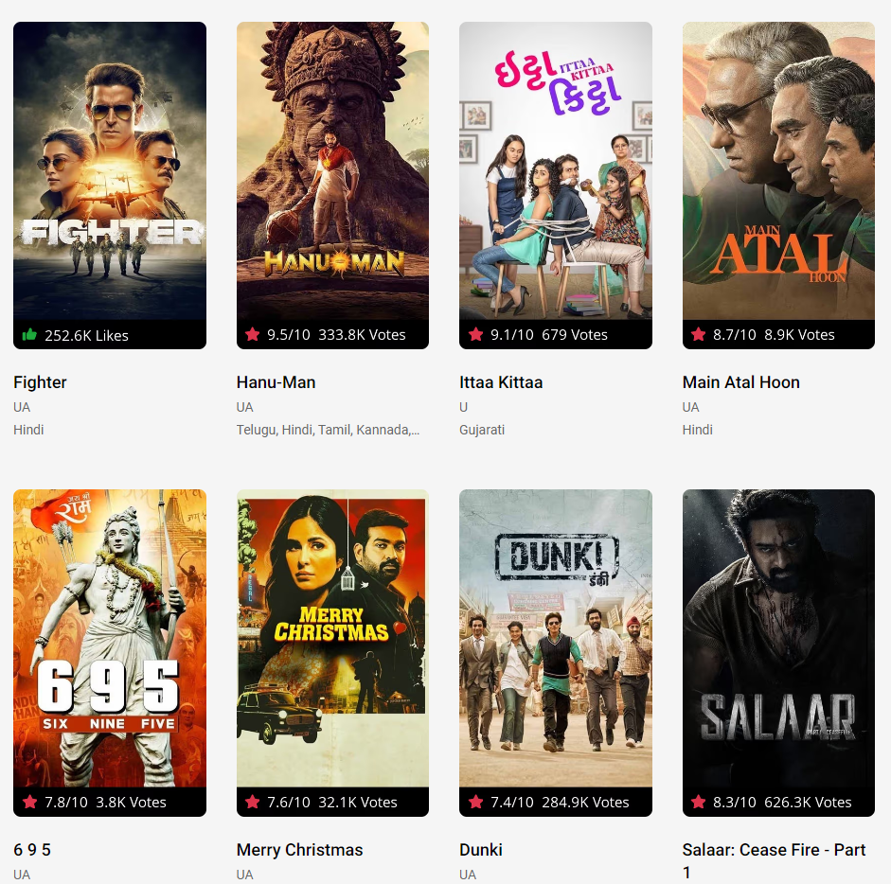

Source : https://in.bookmyshow.com/explore/movies-ahmedabad